# Assignment 1

## Advanced Web Programming – Tom Tsiliopoulos

### Dylan Scott – 200167576



All work Copyright © 2012 by Ravash inc.

All rights reserved.

**Table of Contents**

1. Brief Description
2. Nav Bar
3. Colours
4. Typography

# Brief Description –

My website was designed to act as an active resume and portfolio on the web. It will show anyone that views my website some examples of my work as well as contact information and a bit of information about myself.

# Nav Bar –

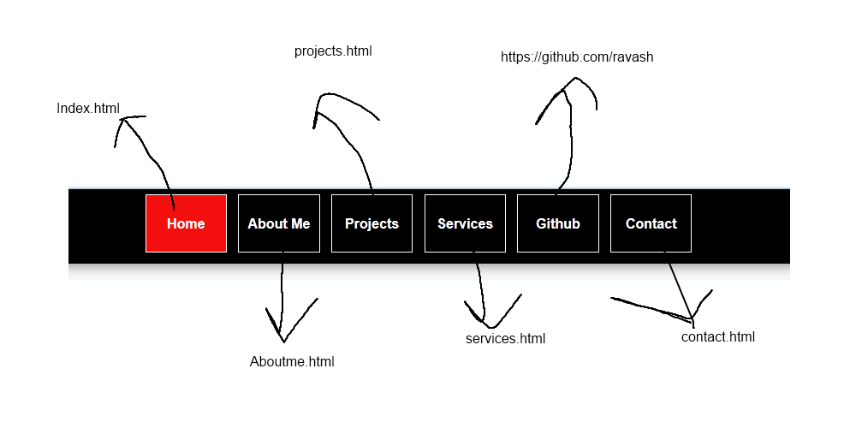

# Colours-

I only really used 3 colours on the whole site.

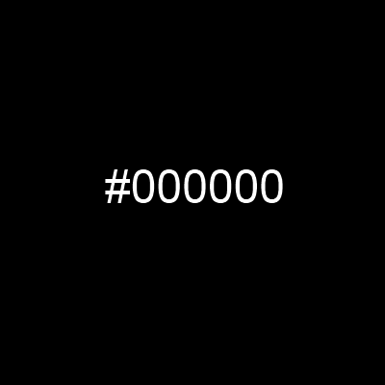

# Typography-

